**VIDEO GUIDE: Internal Insect Morphology**

**Directions:** Watch the video and answer the following questions.

1. The following diagram outlines the parts of the digestive and excretory systems of the insect. Describe the function of the following parts.   
   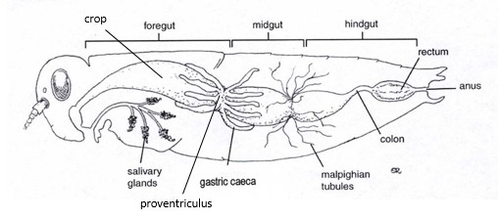
   1. crop – **Acts as a place to store food.**
   2. proventriculus – **Uses tooth-like structure (denticles) to grind food.**
   3. gastric caeca – **Increases surface area between foregut and midgut to aid nutrient intake.**
   4. malpighian tubules – **Handles osmoregulation (controls osmotic pressure by regulating water and salt concentration) and excretion.**
2. Describe the type of circulatory system insects have and the name of their blood.  
   **Insects have an open circulatory system without a network of veins and arteries. Insect blood is called hemolymph and moves freely through the hemocoel, with the aid of the dorsal aorta. The dorsal aorta is the sole blood vessel in insects and pumps hemolymph to the head region**
3. Describe an insect’s nervous system.  
   **Insects have a simple nervous system with a brain in the head and a ventral nerve cord to connect everything up. The anterior end of the nerve cord is called the subesophegal ganglion. The segment through the thorax is called the thoracic ganglia, and the abdominal segment is called the abdominal ganglia. The individual nerve segments coming off the ventral nerve cord are called ganglia. It is likely that insects can feel pain considering their nervous systems are similar, albeit smaller than ours, and they respond to stimuli one would expect to cause pain.**
4. Describe the pathway that gases enter the insect and to the internal organs and tissues.  
   **Insects have a respiratory system separate from their circulatory system. Openings in the exoskeleton called spiracles enable gas exchange. An internal network of tubes called trachea carry oxygen from the spiracles to organs, which are surrounded by tracheoles. As far as the respiratory hierarchy goes, the largest is tracheal trunks, which feed into tracheae, then tracheoles are the final-mile.**
5. Describe what a spermatheca is.  
   **Spermathecae are a specialized reproductive organ in female insects that allows them to store sperm and control sperm use.**